# **Optimal Fertilizer Recommendation Using Machine Learning**

Pratik Bagul Chirag Sing Suraj Hormane

**Abstract**

Imagine a small-scale farmer in rural Maharashtra, struggling year after year with unpredictable crop yields. Despite following traditional fertilizer guidelines, his soil loses fertility, costs rise, and the harvest never meets expectations. This is not an isolated case—millions of Indian farmers face similar challenges due to outdated, generalized fertilizer practices that ignore the complexity of local soils, weather, and crop needs. This research proposes a transformative solution using machine learning (ML) to make fertilizer recommendations smarter, region-specific, and sustainable. By analysing elaborate agricultural datasets—such as soil nutrient levels (NPK), pH, temperature, and rainfall—ML algorithms can generate tailored recommendations that significantly reduce environmental damage and improve crop productivity.[4] The study places strong emphasis on India's diverse agroclimatic zones and soil types, highlighting the need for precision rather than one-size-fits-all approaches. Furthermore, a practical implementation is proposed through a multilingual frontend system featuring an AI-powered, multilingual chatbot integrated with national soil health databases. This user-friendly tool empowers farmers, regardless of language or education level, to access accurate fertilizer advice and even purchase inputs directly online. Through this convergence of data science, agronomy, and accessibility, the research aims to bridge the gap between technology and traditional farming, offering a path towards more efficient and sustainable agricultural practices across India.

**Keywords:** *Machine learning, Fertilizer, Indian agriculture, Soil properties, Agroclimatic zones, AI chatbot, Multilingual, NPK.*

_____________________________________________________________________________________

**1. Introduction**

Modern agricultural systems depend heavily on fertilizers because these products deliver crucial nutrients needed for plant development which determines the quantity of harvested crops. The methods through which farmers apply fertilizers fail to reach their maximum efficiency and sustainability potential. Generalized recommendations which traditional methods use, fail to address the complex soil compositions and crop needs alongside environmental variables that differ between agricultural areas. The improper application of fertilizers results in multiple adverse effects that damage soil health while contaminating water supplies and producing more greenhouse gases from fertilizer manufacturing and excessive use. Traditional fertilization methods produce unreliable results because they often end in either inadequate fertilization that decreases farm output or excessive fertilization that intensifies environmental damage and wastes farmer’s resources. [1] The growing global population creates increasing demands on agricultural systems to increase food output because it highlights the necessity of sustainable and efficient nutrient management approaches.[2] The key challenge emerges from shifting current general approaches into specific data-based strategies that exactly match fertilizer supply with plant requirements.

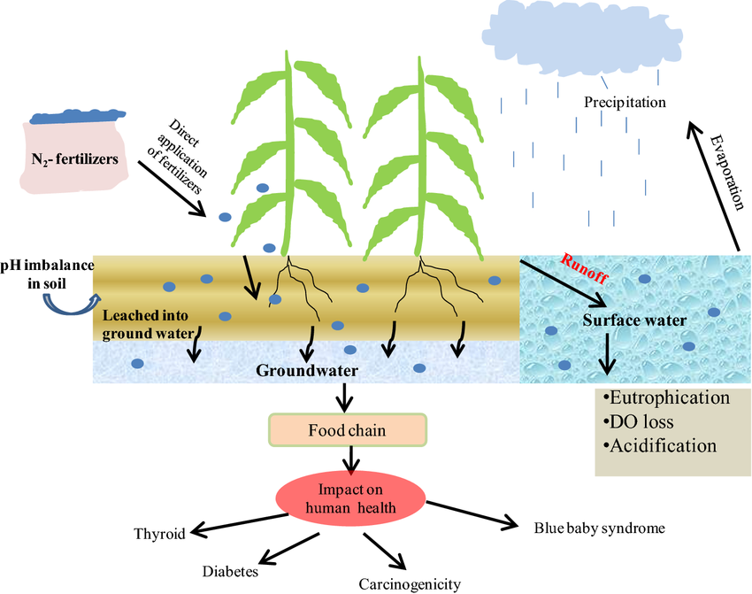

***Figure 1***: *Consequences of over nitrogen fertilization on the environment and human health [34]*

The introduction of precision agriculture brings forward a revolutionary method to transform agricultural operations. Machine learning stands as a transformative technology because it shows promise to revolutionize nutrient management under this framework. [4] By examining complex datasets ML algorithms detect agricultural connections and generate useful decision-making information.[3] The technology proves useful specifically when making fertilizer recommendations because various interacting elements such as soil nutrients and crop stage and weather patterns and crop type demand thorough analysis for proper nutrient decisions. The agricultural field benefits from ML applications because they enable productivity enhancement while reducing environmental impacts and promoting sustainability in farming operations. [4, 5]

The research examines how machine learning techniques determine optimal fertilizer recommendations particularly within the Indian agricultural setting. The first section reviews previous research about this domain while examining the addressed problems and utilized machine learning algorithms and input features along with data handling methods and performance evaluation metrics and significant findings from previous studies. The paper explores the main components that affect fertilizer requirements which encompass soil attributes together with environmental elements and growing requirements. The paper devotes a major segment to study India's regional characteristics through analysis of regional soil types and climate patterns that affect fertilizer management practices. The paper will analyze the implementation of a functional frontend system that includes an AI-based chatbot for NPK value-driven advice delivery and Google Translate capabilities alongside national soil health framework support and online fertilizer purchasing features. This paper explores the effective utilization of machine learning for optimal fertilizer recommendations in Indian agriculture through analysis of current research and practical implementation considerations.

**2. Review of Existing Research**

Modern agricultural research shows strong interest in how machine learning techniques optimize fertilizer recommendation procedures. Research has investigated multiple machine learning approaches to solve issues that exist in conventional fertilizer treatments.[1]Smith et al. developed a machine learning model in 2020 through regression algorithms to offer exact fertilizer recommendations dependent on soil nutrient measurements and crop types and environmental parameters for improved production and reduced environmental effects.[1]Wang et al. conducted a 2022 study where they combined decision trees with random forests and gradient boosting machines through ensemble learning to evaluate soil test data together with crop performance data for improving fertilizer recommendation precision and reliability.[1]Martin et al. (2023) conducted research which showed how linking satellite and drone remote sensing data with numerical soil and crop information leads to optimized fertilizer application practices.[1]The research demonstrates how ML enables the development of data-based fertilization methods that achieve enhanced precision

The achievement of successful ML models depends on obtaining suitable and complete input features. The analysis requires detailed soil data which includes NPK values in addition to pH levels and organic matter content and various micronutrients. The successful operation of these ML models requires precise crop information about types of crops together with their developmental stages and nutrient absorption patterns. The evaluation of past yield data enables models to extract knowledge from historical records which they apply to future recommendation adjustments. The impact of temperature along with rainfall and humidity on crop growth requires these environmental factors to be included as essential inputs. [1, 6] Some studies use location-specific geospatial data for site-specific management. Different channels provide data for these models through laboratory soil analysis of samples and farmer records and meteorological databases and remote sensing satellites and drones and IoT sensors used in agricultural fields.[5]

Multiple important steps must be followed to handle the diverse data types. The data collection

process involves obtaining soil samples for laboratory testing and organizing crop-related information and environmental data access and potential implementation of geospatial tools.[1] The preprocessing stage transforms raw data by conducting cleaning operations to remove inconsistencies followed by normalization to achieve cross-dataset uniformity and then performs feature engineering to extract useful information and finally unifies different datasets into a single format. The preprocessing stage requires multiple essential techniques to deal with missing values and detect outliers and encode categorical variables. The researchers in Tamil Nadu analyzed rice and maize yield data from Kaggle datasets alongside fertilizer records spanning 1997 to 2018 and another study used Power BI for noise removal when analyzing 22 crops with parameters NPK, pH, moisture, temperature, and precipitation using Kaggle data [6].

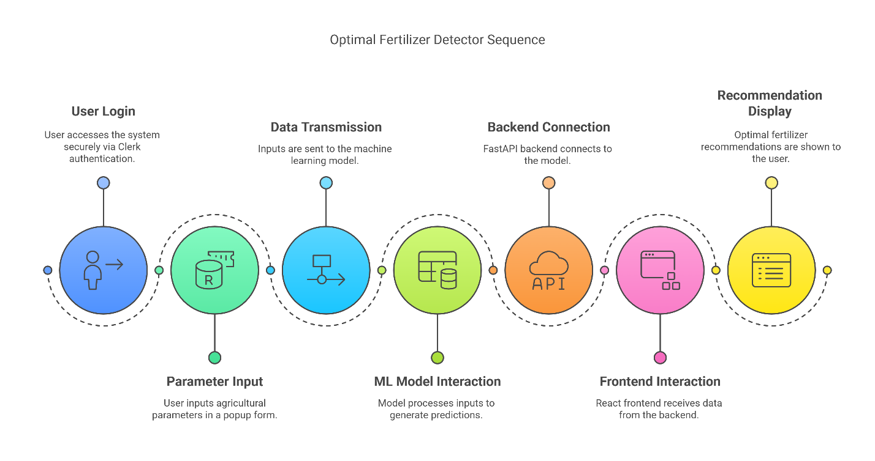

***Figure 2:*** *Workflow of optimal Fertilizer Detector Sequence*

**Figure 2** *illustrates* the user flow of a web-based system designed to provide optimal fertilizer recommendations using machine learning and backend connectivity. The sequence begins with User Login, where the user securely accesses the system via Clerk authentication. This is followed by the Parameter Input stage, where users enter agricultural parameters in a popup form. In the Data Transmission step, these inputs are sent to the machine learning model.

The system then proceeds to theML Model Interaction phase, where the model processes the input data and generates predictions. This is handled through a Backend Connection, specifically using a Fast API framework that interacts with the model. Once the predictions are ready, the Frontend Interaction stage takes place, where React frontend fetches and displays the data. Finally, in the Recommendation Display step, users receive tailored fertilizer suggestions, completing the detection sequence.

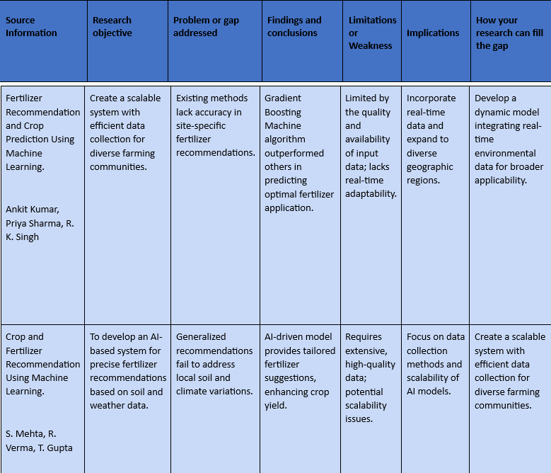

**3. Methodologies**

Machine learning provides multiple algorithmic solutions which effectively address the complexity of fertilizer recommendation optimization. A wide range of machine learning methodologies including regression, classification, clustering, ensemble learning and reinforcement learning techniques serve agricultural applications with particular advantages and constraints. Our system relies on the Random Forest classifier as its main algorithm for fertilizer optimization because it demonstrates both strong performance and clear interpretation capabilities.

**3.1 Random Forest algorithm**

A Random Forest is an ensemble of multiple decision trees. Each tree is trained on a different subset of the data using a technique called bootstrapping (random sampling with replacement). For classification tasks, the final output is decided by **majority voting** from all decision trees. That is:

**Predicted output (ŷ) = mode(T₁(x), T₂(x), ..., Tₙ(x))**

For regression tasks, the output is the **average** of all the tree outputs:

**Predicted output (ŷ) = (1/n) × [T₁(x) + T₂(x) + ... + Tₙ(x)]**

During training, at each node of a decision tree, the algorithm selects the best feature and threshold to split the data by minimizing an impurity measure. The most common one for classification is **Gini Impurity**, which is calculated as:

**Gini(D) = 1 – Σ (pᵢ)²**

Where pᵢ is the proportion of data samples in class **i** in dataset D.

The algorithm chooses the split that minimizes the **weighted average impurity** of the two resulting child nodes:

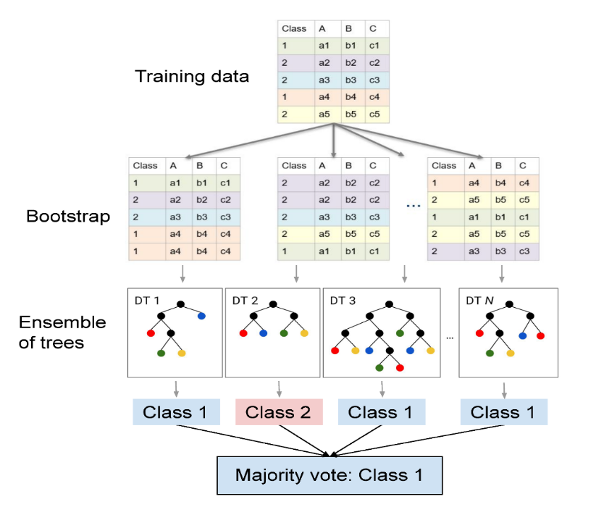**Gain(D) = Gini(D) – [ (|Dₗ|/|D|) × Gini(Dₗ) + (|Dᵣ|/|D|) × Gini(Dᵣ) ]**

Where Dₗ and Dᵣ represent the left and right subsets of the split, and |D| represents the number of samples in the dataset.

One of the strengths of Random Forest is its ability to calculate **feature importance**. The importance of a feature is measured by how much it reduces impurity across all trees:

**Feature Importance(f) = Sum of impurity decrease caused by feature f across all trees**

These mathematical techniques allow Random Forest to detect complex patterns and interactions between agricultural variables like soil nitrogen (N), phosphorus (P), potassium (K), pH levels, temperature, and crop type. This makes it an ideal choice for precise fertilizer recommendation systems.

**Figure 3***:* Diagram illustrating the Random Forest classifier process*.* Shows bootstrapping, random feature selection, and ensemble aggregation combine to form the overall classifier, highlighting the stages of data sampling, tree construction, and final prediction aggregation

**4. Key Determinants of Fertilizer Requirements**

The process of finding the right fertilizer amount for a particular crop in its designated location involves analyzing multiple essential factors. The fertilizer requirements depend on three key factors: the natural characteristics of soil and environmental elements and the nutritional needs of the cultivated crop.

**4.1 Soil Properties**

Field nutrient status and plant growth potential depend on the fundamental properties of soil. The three fundamental soil macronutrients which are most important for plant growth include Nitrogen (N), Phosphorus (P) and Potassium (K). [1, 2, 6] Nitrogen supports vegetative growth while Phosphorus promotes chlorophyll development. The fundamental role of phosphorus in root development and flowering and fruit formation has been established by research. At the same time potassium supports plant health and disease resistance and stress tolerance [1, 14]. The quantity of organic matter found in soil plays a vital role in overall agricultural functions. Soil organic matter improves both soil structure and water retention ability and functions as a nutrient reservoir that releases nitrogen and phosphorus through decomposition. [1, 6, 7] Besides major nutrients, various micronutrients play essential roles in plant functions although needed in smaller amounts. Soil type together with texture determines both nutrient accessibility and water retention capacity of the soil. The assessment of soil properties requires thorough evaluation because it directly impacts the development of suitable fertilizer recommendation.

**4.2 Environmental Factors**

Both the availability of soil nutrients and plant bringing up of these nutrients depend on continuously changing environmental conditions. Plant roots need watering through rainfall or irrigation to dissolve fertilizer substances which enables their absorption from the soil.[1] Heavy rainfall creates the condition for nutrient drainage as it washes away soluble nutrients such as nitrogen and potassium from sandy soils. Humidity affects the rate of transpiration in plants, which in turn impacts nutrient uptake. Low humidity can increase transpiration rates, which can result to a higher demand for water and nutrients, while high humidity can reduce transpiration and reduce the plant's ability to absorb water and fertilizers.[18, 19] Temperature also plays a significant role, affecting plant growth rates, nutrient uptake, and the activity of soil microorganisms that are involved in nutrient cycling.[1, 6, 7] Solar radiation is another important environmental factor that drives photosynthesis and overall plant growth, indirectly influencing nutrient requirements.[7] Knowledge of current and expected environmental conditions should guide fertilizer recommendations in order to optimize how nutrients are applied.

**4.3 Crop Needs**

The particular nutritional requirements between different crops cultivated represents one of the essential determinants which influences fertilizer needs. Various plant species require different amounts macronutrients and micronutrients at specific stages of their growth period.[1] Leafy vegetables typically need increased nitrogen during their vegetative stage but fruit-producing plants require higher phosphorus and potassium when they flower and bear fruit. Proper fertilizer applications require knowledge of how a specific crop consumes nutrients across its development stages. Understanding past crop cultivation patterns in a field gives important information about soil nutrient depletion and future fertilizer needs. To achieve optimal crop nourishment and yield effectiveness fertilizer recommendation systems need to gather information about the specific crop type together with its growth phase and its unique nutrient requirements. The multiple interactions between soil characteristics with environmental elements and crop demands make it challenging to determine proper fertilizer amounts while machine learning provides essential methods to analyze all these interconnected variables as a whole.[6]

**5. Regional Specificity in India**

The vastness of India includes multiple soil types together with diverse climate zones that deeply affect how farmers perform their agricultural work especially in matters of fertilizer management. The development of sustainable fertilizer recommendations for India requires understanding the regional differences throughout the country.

**5.1 Soil Types**

The Indian geographical area contains different main soil types which show distinct nutrient levels across distinct territorial areas. The northern plains together with river valleys contain extensive alluvial soils which originate from sediment deposits of the Indus Ganga and Brahmaputra rivers.[21] The land of these soils features high concentrations of potash and lime yet shows low levels of nitrogen and phosphorus content. Black soils or regur soils represent the Deccan plateau region while exhibiting high levels of iron and lime and calcium carbonate and magnesium and potash and low contents of phosphorus nitrogen and organic matter[22]. Soils in eastern and southern Deccan plateau regions exist as red and yellow deposits which contain high levels of iron and potash but have low levels of nutrients and humus.[23] The Western Ghats along with parts of the Eastern Ghats possess laterite soils that contain iron and aluminum yet lack nitrogen, potash, phosphorus and calcium and magnesium. The Thar Desert of Rajasthan and Gujarat contains arid soils which are characterized by sandiness and salinity and the absence of moisture alongside organic matter. Soils in forest areas generally occur in mountainous and hilly territories while showing varied compositions which usually present acid conditions and low levels of humus.[21] The process of developing effective fertilizer recommendations requires knowledge about how different soil types across regions possess distinct nutrient strength and weaknesses.

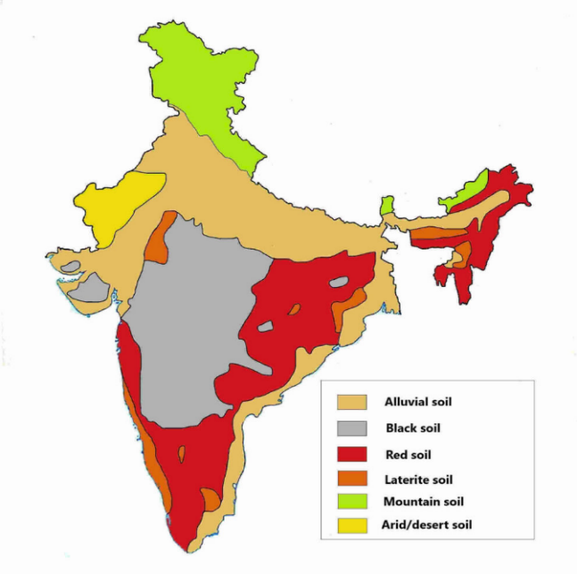

**Figure 4**: Map of India showing the distribution of major soil types across different regions.[21]

**5.2 Climate Variations**

The different agroclimatic zones in India show major variations in their moisture content and humidity levels. The extensive coastlines in South India create a climate that is warmer and more humid in nature. The nation displays various climate types including tropical wet conditions on the Malabar Coast and Northeast India that bring heavy rain and high humidity and the tropical savanna climate dominating inland peninsular regions with wet and dry seasons. The arid and semi-arid areas of Rajasthan

together with parts of Gujarat receive poorly predictable rainfall which leads to minimal humidity throughout their hot summer season. The subtropical humid climate exists throughout Northeast and North India where summers are warm and rains from the monsoon season are plentiful.[17] The Himalayan mountains display various climatic patterns because altitude determines the specific conditions found in each section. The local differences in humidity and moisture levels directly affect how farmers manage their fields and how they should use fertilizers.

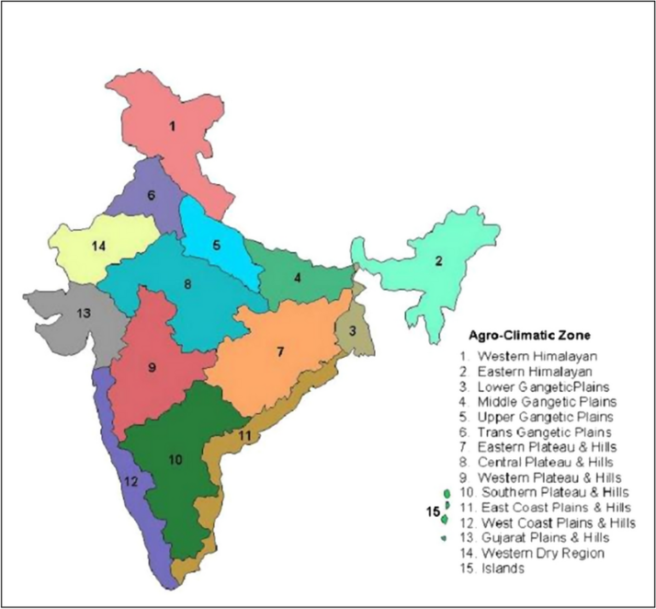

**Figure 5:** A map showing India's various agroclimatic zones, highlighting regional climate variations and their implications for agriculture.[35]

**5.3 Fertilizer Strategies**

The effect of climate changes on fertilizer usage requirements proves to be significant. The high levels of rainfall and humidity enhance soil nutrient leaching which means farmers need to apply more frequent doses of nitrogen and potassium fertilizers. Water-deficient regions require specific fertilizer management to prevent soil salinity accumulation so water-soluble fertilizers applied through irrigation demonstrate better results. The application of fertilizers in monsoon-dependent areas should match seasonal water access opportunities to optimize nutrient absorption and prevent waterborne nutrient waste. The effective

nutrient management systems depend on how soil type interacts with climatic factors. Different fertilization approaches should be used because sandy soils in high rainfall areas lose nutrients through leaching while clay soils in the same region need different strategies. [17] Recommendation systems for India need to account for regional variations in soil types and climatic conditions because this will enable precise nutrient recommendations for improving agricultural productivity throughout the country.

**Table 1: Major Soil Types in India and Their Nutrient Profiles**

|  |  |  |  |
| --- | --- | --- | --- |
| Soil Type | Key Regions of Prevalence | Typical Nutrient Strengths | Typical Nutrient Weaknesses |
| Alluvial Soil | Northern Plains, River Valleys, Eastern Coastal Plains | Rich in Potash, Lime | Low in Nitrogen, Phosphorus |
| Black Soil | Deccan Plateau (Maharashtra, Madhya Pradesh, Gujarat, etc.) | Rich in Iron, Lime, Calcium Carbonate, Magnesium, Potash | Poor in Phosphorus, Nitrogen, Organic Matter |
| Red and Yellow Soil | Eastern and Southern Deccan Plateau, Parts of Odisha, Chhattisgarh, West Bengal | Rich in Iron, Potash | Poor in Nutrients, Humus |
| Laterite Soil | Western Ghats, Parts of Eastern Ghats, Hilly Areas of Odisha and Assam | Rich in Iron, Aluminum, Manganese | Poor in Nitrogen, Potash, Phosphorus, Calcium, Magnesium |
| Arid Soil | Rajasthan, Parts of Gujarat | Sandy, Saline | Lacks Organic Matter, Moisture, Low in Nitrogen |
| Forest Soil | Hilly and Mountainous Regions (Himalayas, Western Ghats, Northeast) | Varies, can be rich in Organic Matter, Nitrogen, Phosphorus, Potassium | Often Acidic, Low Humus Content in Snow-Covered Areas |
| Peaty and Marshy Soil | Delta Regions (Bengal Delta), Coastal Areas (Kerala, Tamil Nadu) | Rich in Organic Matter, Nitrogen | High Salinity, Deficient in Potash, Phosphate |
| Saline and Alkaline Soil | Rajasthan, Haryana, Punjab, Uttar Pradesh, Bihar, Maharashtra, Parts of Gujarat, Andhra Pradesh, Karnataka | High Content of Soluble Salts (Sodium Chloride, etc.) | Nutrient-Poor, Lacks Moisture, Low Humus Formation |

**6. Practical Solution**

Creating a functional fertilizer recommendation system requires advanced machine learning models together with simple interfaces that connect to current agricultural systems. A frontend project consisting of an AI-powered chatbot combined with Google Translate while connecting to national soil health initiatives and simplifying fertilizer acquisition offers an extensive solution to achieve this objective.

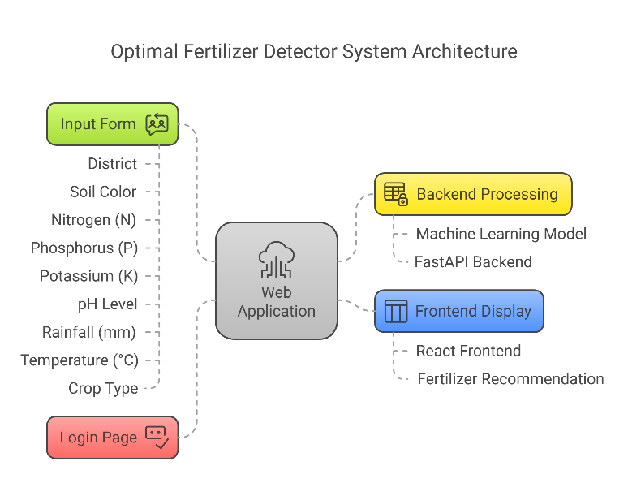

***Figure 6****: Image showing optimal fertilizer detector system architecture*

**Figure 6** *illustrates* the overall system architecture of the Optimal Fertilizer Detector. It begins with a Login Page, where users authenticate themselves before accessing the system. Once logged in, they are directed to the Input Form section, where they provide key agricultural parameters such as district, soil colour, nitrogen (N), phosphorus (P), potassium (K), pH level, rainfall (mm), temperature (°C), and crop type.

These inputs are sent to the Web Application, which acts as the central hub of the system. The web application then interacts with the Backend Processing module, which includes a machine learning model integrated via a Fast API backend. This module processes the user input to generate precise fertilizer recommendations.

The final output is delivered through the Frontend Display, which uses a React-based interface to present the fertilizer suggestions in a user-friendly format. This system architecture ensures an efficient data flow from input to output, leveraging intelligent backend computation and modern frontend design for optimal performance and user experience.

**6.1 Integrating the Frontend Project**

The implementation of an AI-based chatbot provides farmers with an interactive platform to receive immediate fertilizer recommendations. Users can input their soil NPK values into the chatbot system which enables the backend machine learning models to create personalized recommendations. The chatbot system should ideally process more than NPK values by integrating location data (state and district) with soil property information (pH and moisture) to boost recommendation accuracy.[20] The reliability of recommendations increases through the combination of historical data with expert agricultural knowledge from the Indian Council of Agricultural Research (ICAR) guidelines. The chatbot makes crop and fertilizer suggestions to users through their entered state information and soil pH measurements and another system predicts fertilizer amounts using historical data combined with ICAR sources.[24] The user interface of the chatbot system needs to provide an intuitive experience for farmers who possess different levels of technical expertise.

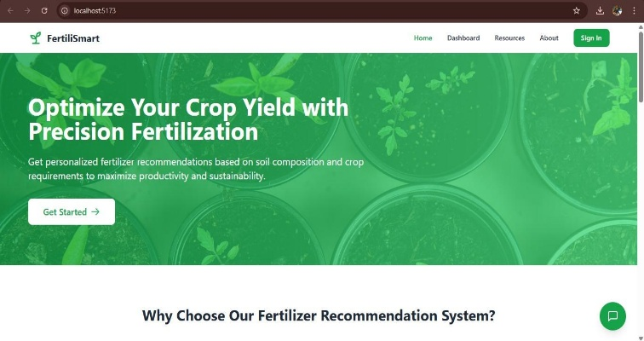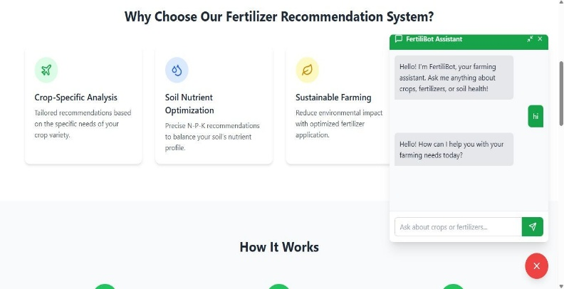

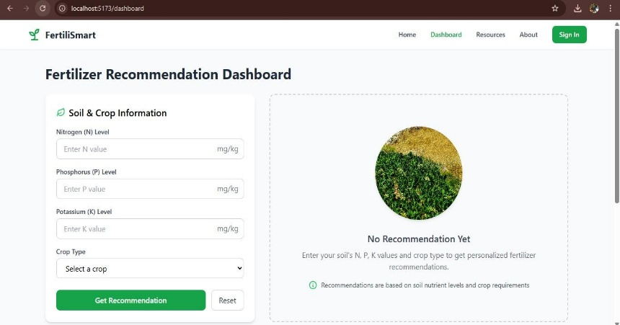

**Figure 7**: Mockup of a user interface for an AI-powered chatbot designed for fertilizer recommendation.

The widespread adoption of such a system depends on providing multilingual support because India possesses diverse linguistic characteristics. The Google Translate API integration enhances chatbot accessibility because it enables farmers to communicate with it through their native languages. [1] Users benefit from the Google Cloud Translation AI which handles different content types along with API deployment and offers translation support across numerous languages. [25] The ML Kit translation system contains an API that allows on-device language translation of more than fifty languages and would prove useful for basic text interpretation when internet access is restricted. [26] The chatbot needs to identify user languages automatically or let users select their language to maintain smooth communication.

The proposed ML-based fertilizer recommendation system operates harmoniously with the current national soil health initiatives including the Soil Health Card Scheme. The Soil Health Card delivers vital information regarding soil nutrients to the farmers [33]. The ML-powered chatbot functions as an automated interpretation system for Soil Health Cards data which gives farmers detailed fertilizer advice that matches their NPK metrics and other recorded parameters. [1] Additional process enhancement would be possible if integration with the Soil Health Card Portal becomes practical because it would enable the chatbot system to obtain farmer-specific soil health data automatically for enhancing recommendation accuracy. The alignment between these systems will strengthen the government's initiatives for promoting soil test-based and balanced fertilizer use.

The frontend project should include information about online platforms for fertilizer buying as part of its comprehensive solution.[1] The Indian market features several online fertilizer retailers which operate under Utkarshagro.com Bighaat.com Ugaoo.com IFFCOBazar.com and Agribegri.com. [27, 28, 29] Users who obtain fertilizer recommendations from the chatbot would be guided to appropriate online platforms to browse and acquire the suggested fertilizers. The integrated experience enables farmers to follow expert recommendations while easily obtaining needed inputs which drives farmers to implement best fertilization methods.

**7. Conclusion**

The research shown in this study demonstrates how machine learning changes the way we recommend fertilizers in contemporary agricultural practices throughout diverse regions of India. We have studied existing research to showcase how multiple ML algorithms solve nutrient management challenges including specialized fertilizer prediction and soil type classification together with sustainable environmental adaption. The paper has studied how soil characteristics together with environmental conditions and crop requirements define proper fertilizer methods while demonstrating data-based solutions outperform conventional generalized recommendations. The research identifies major climate and soil diversity throughout India which proves why location-specific fertilizer recommendation systems remain essential. New customers will benefit from an AI-enabled chatbot, multiple language capability and federation with national initiatives and direct market entry for fertilizers through a user-centric interface. This practical solution aims to give farmers the tools for sustainable agricultural nutrient management. The combination of improving machine learning technology and increasing precision agriculture commitment makes room for optimal fertilizer recommendations to drive future crop production improvements with better soils and less environmental strain.

**References**

[1] Smith et al., 2020, Research on Machine Learning for Fertilizer Recommendation.

[2] Bhanumathi et al., 2019, Application of Machine Learning in Agricultural Production and Fertilizer Recommendation.

[3] Research on Precision Agriculture and IoT for Data Collection.

[4] Research on Machine Learning for Nutrient Management.

[5] Wang et al., 2022, Ensemble Learning Techniques for Soil Test Analysis.

[6] Research on Crop Prediction using Machine Learning.

[7] Bernardini, Review of Machine Learning Techniques for Fertilizer Estimation (Part 1).

[8] Bernardini, Review of Machine Learning Techniques for Fertilizer Estimation (Part 2).

[9] Gautam et al., 2010, Evaluation of Nutrient Expert and Machine Learning for Nutrient Management in Cereals.

[10] Study on Performance Metrics for Machine Learning Models.

[11] Study on Precision and Recall in Machine Learning.

[12] Comparison of Machine Learning Algorithms in Agricultural Applications.

[13] Research on Reinforcement Learning for Nitrogen Fertilizer Application.

[14] General Knowledge on the Role of NPK in Plant Growth.

[15] Information on Soil pH and Nutrient Availability.

[16] General Knowledge on Crop-Specific Nutrient Requirements.

[17] Information on Climate Variations and Their Impact on Agriculture in India.

[18] Research on Humidity and Plant Transpiration.

[19] Study on the Effects of Humidity on Nutrient Uptake in Plants.

[20] Information on Agrosahakar Chatbot.

[21] Information on Alluvial Soils in India.

[22] Information on Black Soils in India.

[23] Information on Red and Yellow Soils in India.

[24] Information on Chatbot for Fertilizer Dosage Prediction using ICAR Data.

[25] Information on Google Cloud Translation AI.

[26] Information on ML Kit's On-device Translation API.

[27] Information on Utkarshagro.com.

[28] Information on Bighaat.com.

[29] Information on Ugaoo.com.

[30] Research on Real-time Soil Fertility Mapping.

[31] Information on the Soil Health Card Scheme.

[32] Details about the Soil Health Card Scheme.

[33] Benefits of the Soil Health Card Scheme.

[34] Ahmad (2017). Excessive use of nitrogenous fertilizers: An unawareness causing serious threats to environment and human health.

[35] Understanding vulnerability of agricultural production system to climatic stressors in North Indian Plains: a meso-analysis